**Installation:**

* To install nginx, we can simply use **“yum install nginx”** command.
* Once we install, we can see the nginx process running and we can access the homepage of nginx with the public IP of server from the browser.

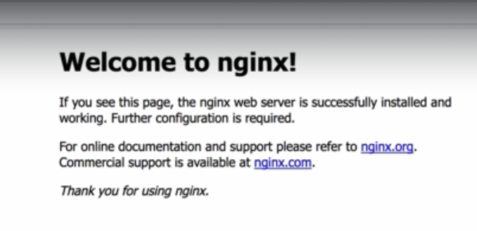

* It runs on default HTTP port 80.
* **“/etc/nginx”** is the default location of nginx configuration files

**Some commands:**

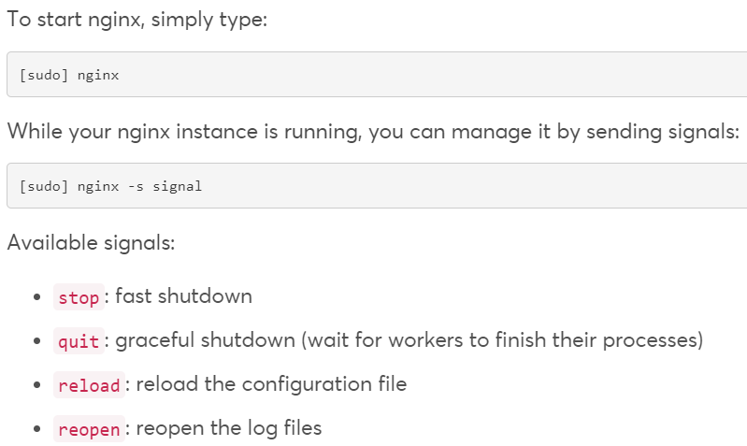

* **“nginx -h”** is to check the nginx commands.
* **“nginx -s stop”** is the command to stop the service.
* We can see the nginx running with master and worker process as below.

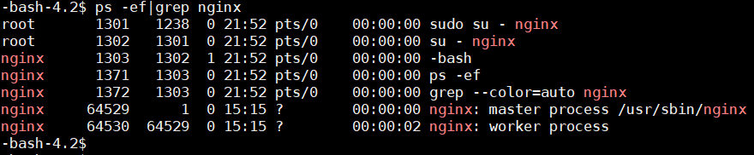

We can kill that master process, or we can send the single to QUIT the master process for graceful shutdown.

* **Kill -9 64530**
* **Kill -s QUIT 64529**

**Run nginx as a service:**

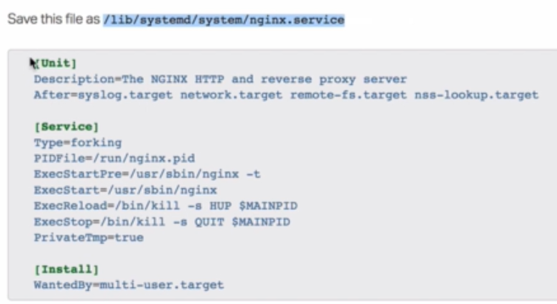

Use the above script and create nginx.service file in the above given path to run the nginx as a service.

Now, we can use systemctl commands to start or stop the nginx as below.

* **Systemctl start nginx**

Once we start the service, it displays the nginx PID, cpu and memory using by nginx and the last few logs as below.

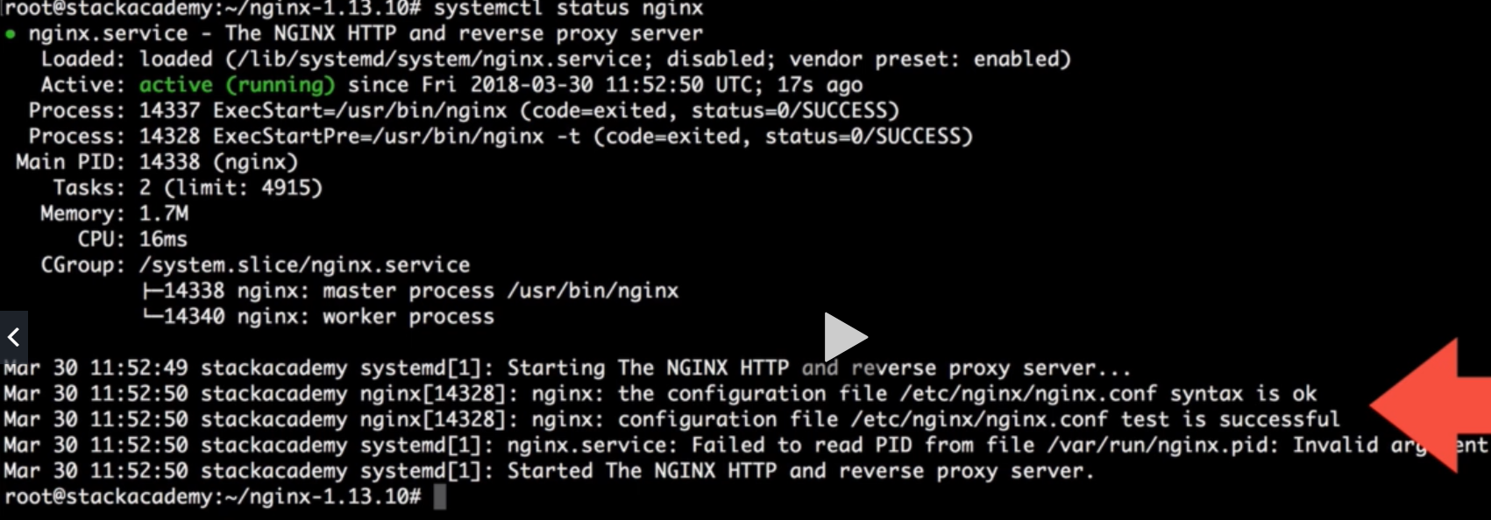

* **Systemctl enable nginx**

We can use the above command to start the nginx every time we restart the machine.

* **Systemctl reload nginx**

The above command reloads the nginx configurations if we make any changes in config file